All students have access to the online textbook. Below are instructions on how to log into the textbooks.
Math
To access the 6th grade math textbook online:
- Go to http://connected.mcgraw-hill.com/connected/login.do
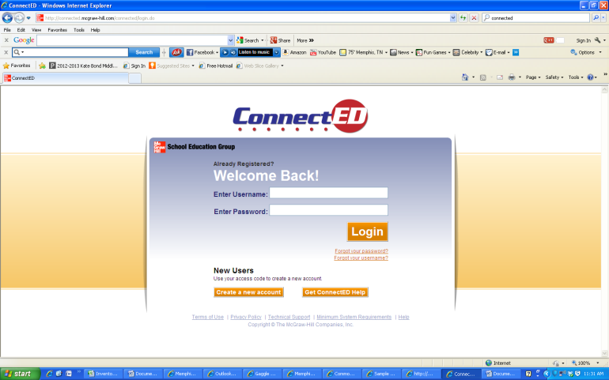
2. Click on create new account.

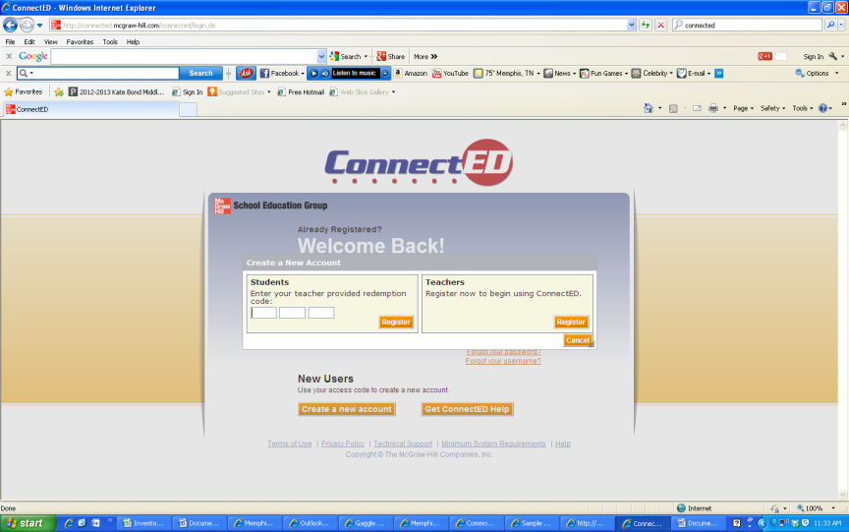
3. Enter redemption code:
TPPV-RCVP-QV70 (6th grade only)

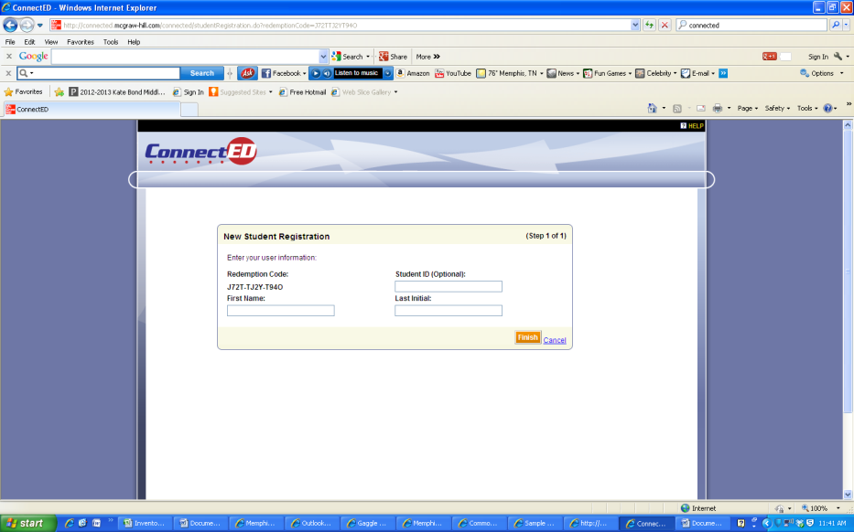
4. Register using your first name and last initial then click finish.

To access Language Arts and Science online textbooks
1. Go to https://my.hrw.com/
2. Username: kgrade6, Password is student

To access the social Studies online textbooks
1. Go to http://glencoe.com/ose/
2. Enter access code:
BE499C0239 (6th grade),

